17.AIM:-To implement UML diagrams for Vehicle Registration Number Registering System…

1.SEQUENCE DIAGRAM:

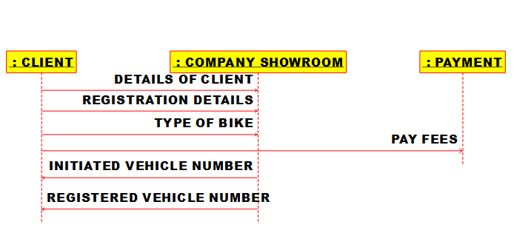

2.CLASS DIAGRAM:

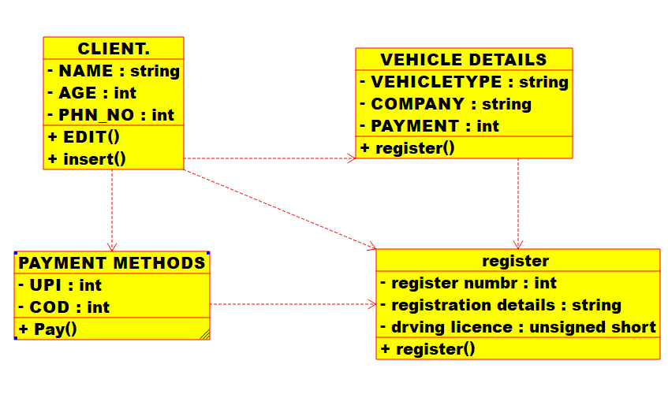

3.PACAKAGE DIAGRAM:

